1.Rewrite the following if statements using the conditional operator.

if (ages>=16)
ticketPrice = 20;
else
ticketPrice = 10;

2.Rewrite the following conditional expressions using if-else statements.
  - score = (x > 10) ? 3 * scale : 4 * scale;

  - tax = (income > 10000) ? income * 0.2 : income * 0.17 + 1000;

  - System.out.println((number % 3 == 0) ? i : j);

3.(Game: scissor, rock, paper) Write a program that plays the popular scissor-rock-paper game. (A scissor can cut a paper, a rock can knock a scissor, and a paper can wrap a rock.) The program randomly generates a number 0, 1, or 2 representing scissor, rock, and paper. The program prompts the user to enter a number 0, 1, or 2 and displays a message indicating whether the user or the computer wins, loses, or draws.
4.
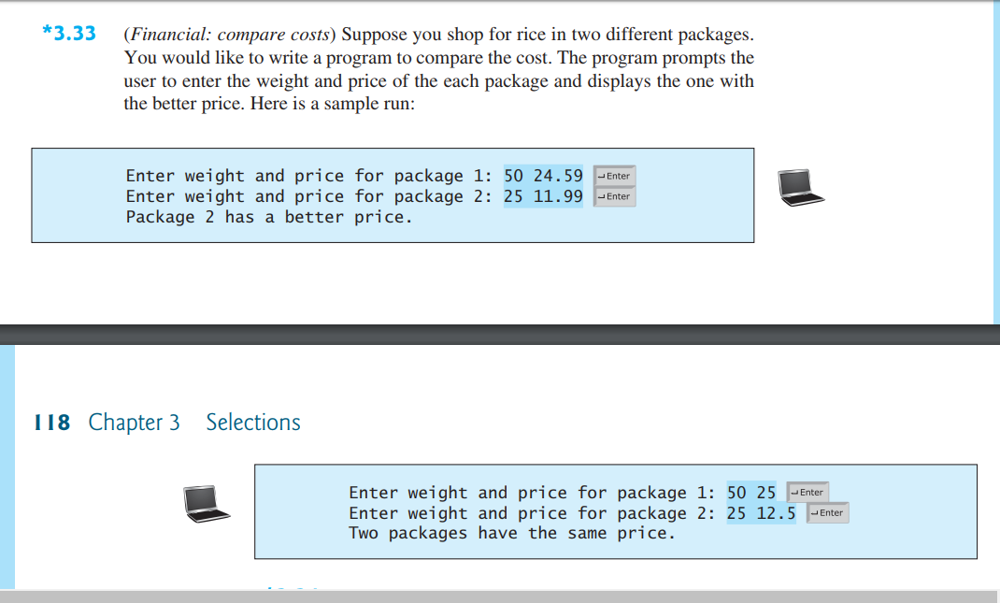
5.s
